## Overview

## This document contains the software design and implementation for an Implement Module.

## The Implement module software manages the interaction between a tractor and its Implements (attachments aiding in the Farming process).

## Requirements

## Implement Module

## Accept multiple types of Implements.

## Accept commands externally.

## Implement

## Each Implement has an industry recognized communication protocol.

## Command – turn on/off.

## Metry – Implement state on/off.

## Metry – fuel level (gasoline or pesticide).

## System Diagram

Blade-Box Implement

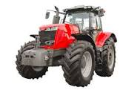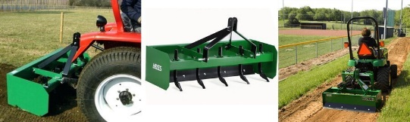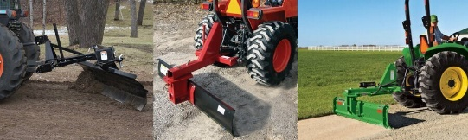

Tractor System

Blade Implement

Snow Blower Implement

## Use Cases

## Use Case Diagram

## 